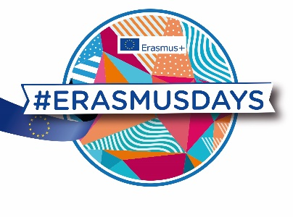
PRESS RELEASE 08/10/19

On the 10, 11 and 12th of October
let’s celebrate european projects during the #ErasmusDays!

More than 3300 events have been registered on www.erasmusdays.eu to celebrate the 2019 edition of the #ErasmusDays. The #ErasmusDays showcase the European impact in the territories thanks to success stories and testimonies. The 10 million European citizens who have experienced an Erasmus mobility since the launch of the programme are invited to share their international experience and to incite citizens to study or train abroad.
Educational and training institutions, companies, research centers, employment agencies, organizations and NGOs… So many international players from school education, higher education, adult education, vocational training, youth and sport, have organized an event and have gathered citizens, journalists and decision makers to join.
51 countries will take part in the 2019 edition:
Albania, Armenia, Austria, Belgium, Bulgaria, Cambodia, Cameroun, Canada, Croatia, Cyprus, Czech Republic, Denmark, Egypt, Estonia, Finland, France, Georgia, Germany, Greece, Hungary, Iceland, Indonesia, Ireland, Italy, Ivory Coast, Kazakhstan, Latvia, Liechtenstein, Lithuania, Luxembourg, Malta, Moldavia, Montenegro, Niger, Norway, Pakistan, Poland, Portugal, Republic of Northern Macedonia, Romania, Serbia, Spain, Slovakia, Slovenia, Sweden, The Netherlands, Togo, Turkey, Ukraine, United Kingdom, Uzbekistan.

The #ErasmusDays expand throughout the world thanks to the involvement of 39 Erasmus + National Agencies, the support of the European Commission (DGEAC) and the European Parliament. This celebration shows locally what European Union brings to citizens.

>>> Seminars, open doors, partner meetings, photo exhibitions, concerts, radio shows, conferences, food tasting… Many events are organized. This diversity illustrates the wide variety of citizens concerned by the Erasmus + programme: students, trainers, teachers, job seekers, companies, organizations, municipality…etc. Parents, decision makers, and professionals are invited to join the events near them.

Here are examples of events organized:

France (1200 events)
The Marseille Academy will gather its students from vocational schools around a fashion show, a DJ set, hairdressing and make-up workshops.
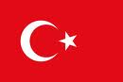
Turkey (373 events)
Atatürk University in Erzurum will show how the Erasmus + project PLANETISE enables to raise awareness of environmental issues among the young population.

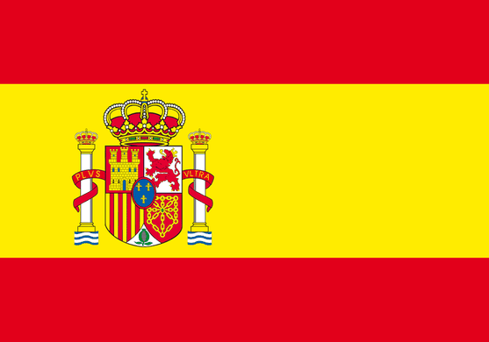
Spain (248 events)
In the Institut Torre Vicens in Lleida, VET students will explain their internships in different companies in France, Germany, Italy and the United Kingdom in the field of aesthetic, construction and health in front of students and local companies.
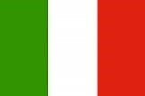
Italy (238 events)
Laura Bassi High School in Bologna organizes an online conference about e-Twinning with its six European partners.

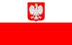
Poland (159 events)
A student career forum will be set up in Cracow University of Economics, where European employers will present their internship offers for students and graduated.

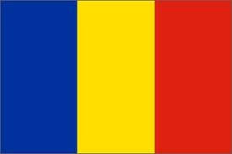
Romania (143 events)
The school of Ramnicu Valcea, that has the European school label, will invite school community and other local institutions to debate about their European dimension and its impact on the evolution of their students.

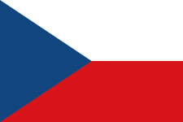
Czech Republic (132 events)
The Biskupské gymnázium in Brno will present its Erasmus+ projects through biological laboratory workshops, media literacy workshops and model lessons held by project participants; an open house, talks, meetings and online quizzes.

Germany (126 events)
A virtual event will be held on hostingtransformation.eu website, where a couple of people will present a methodology and/or their personal experience in adult education sector. Then the audience and the speakers will engage a dialogue.
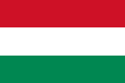
Hungary (81 events)
The school of Budakeszi will organize a flashmob recorded by a drone. There will be reports about finished and ongoing Erasmus + projects.

Outside EU:
Armenia (1 event)
The National Erasmus+ Office in Armenia invite students, researchers, graduates and alumni to attend their open house to raise awareness on scholarship opportunities offered by Erasmus+.
Cambodia (1 event)
The "Cambodian Days", organized jointly by the French Embassy in Cambodia and Campus France, aim to promote Erasmus + projects, and scientific and academic cooperation between Cambodian and French institutions.
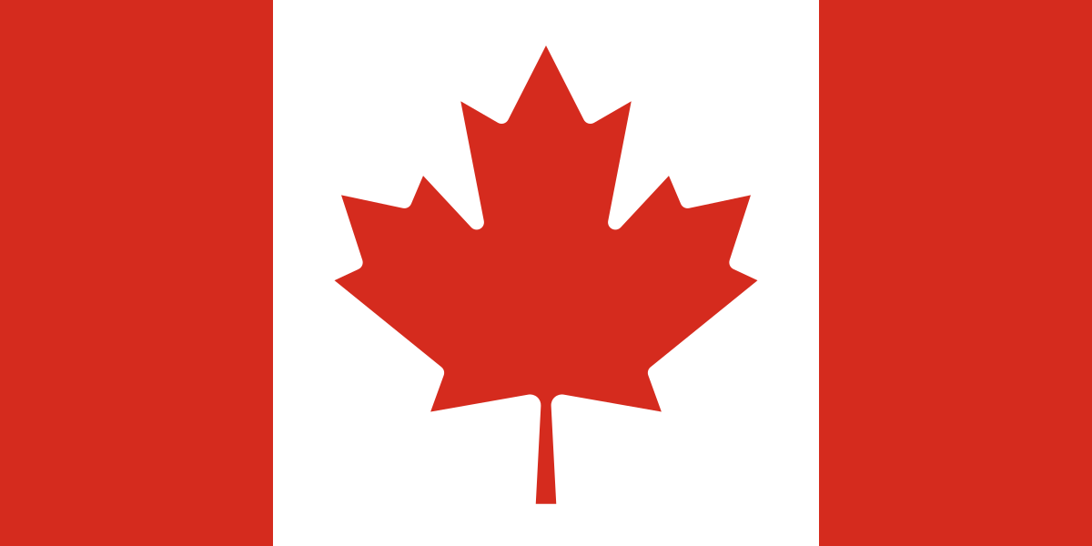
Canada (1 event)
The Alliance Française in Halifax will organize a Speak dating where participants will be invited to practice their French and other European languages.

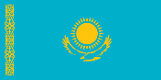
Kazakhstan (33 events)
Dulaty University in Taraz will present its Erasmus + project that aims to train teachers to innovative education tools.

Niger (1 event)
The Abdou Moumouni University with the support of the French Embassy organizes a conference about Erasmus + to better understand the programme and inform the students about their opportunities.
Pakistan (1 event)
The University of Engineering and Technology of Karachi organize an “Ideathon”: young engineers will showcase their creative projects and pitch there valuable ideas in a competition which have international panel of judges.
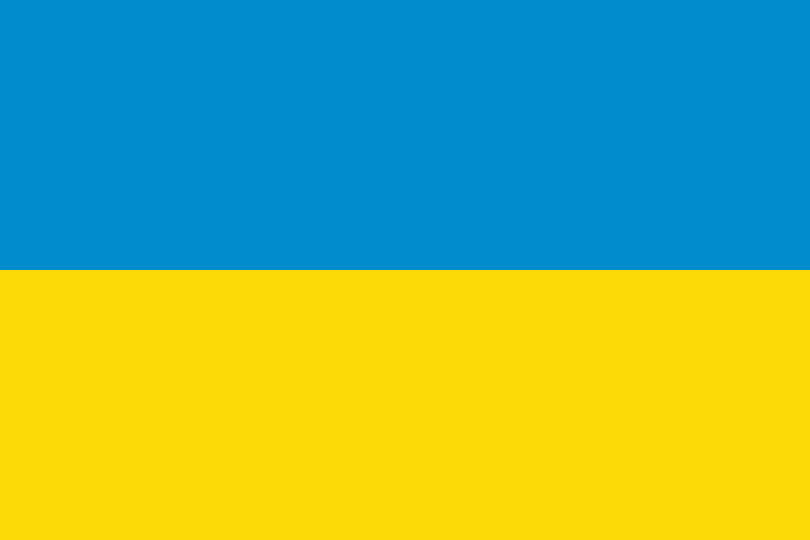
Ukraine (22 events)
An educational film projection about climate change will be held at the private higher education institute of Kharkiv.

A European photo exhibition
During the #ErasmusDays, the adult learning European photo exhibition will showcase Erasmus + projects dealing with inclusion issues. This photo exhibition is available online (https://epale.ec.europa.eu/). Posters from each participating countries in the exhibition is available for free downloading on the EPALE platform so that each actor involved in adult learning in Europe could organize an event for the #ErasmusDays.

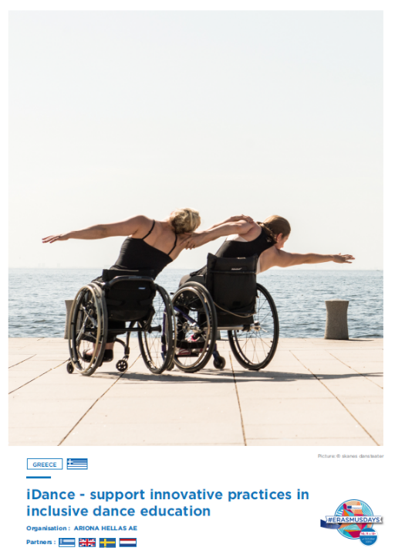
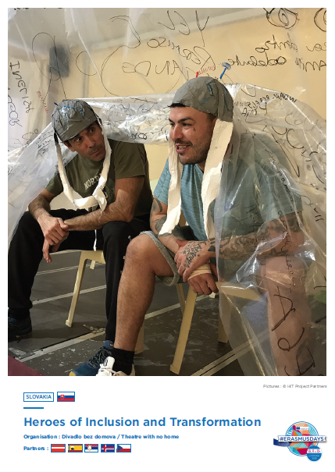

EPALE is a platform for adult learning professionals in Europe. It gathers a community of over 42000 European professionals who share content related to adult learning, including news, blog posts, resources, and events. Through these diverse activities, EPALE‘s goals is to encourage social and professional inclusion for all adults, throughout their whole life, especially disadvantaged groups who need them most.

PRESS RELATION CONTACT
XXX

COMMUNITY MANAGER
XXX

#ERASMUSDAYS COORDINATOR
XXX

